We analyzed covid_clean_3_no_missing_values using the CorrelationAttributeEval technique, which uses a Ranker search method. The result is shown below.

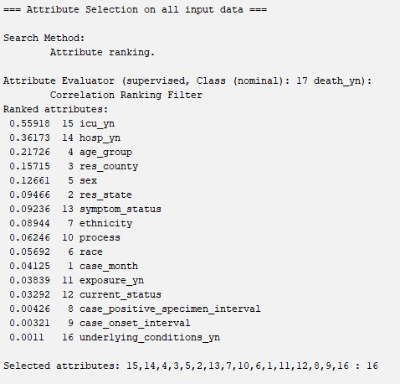

Using a fairly arbitrary cutoff of 0.1, we drop every attribute below (and including) res_state. This leaves us with just icu_yn, hosp_yn, age_group, res_county, and sex. The resulting dataset is saved as covid_CorrelationAttributeEval.